Using Stored Procedures in EF Core

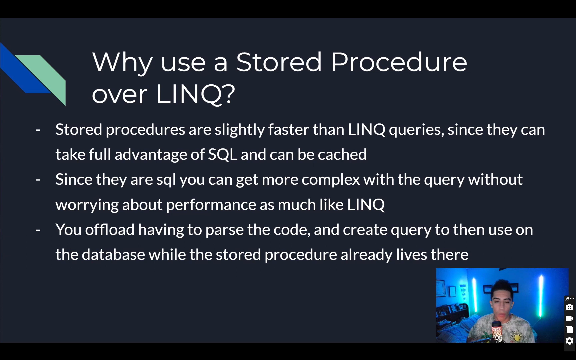

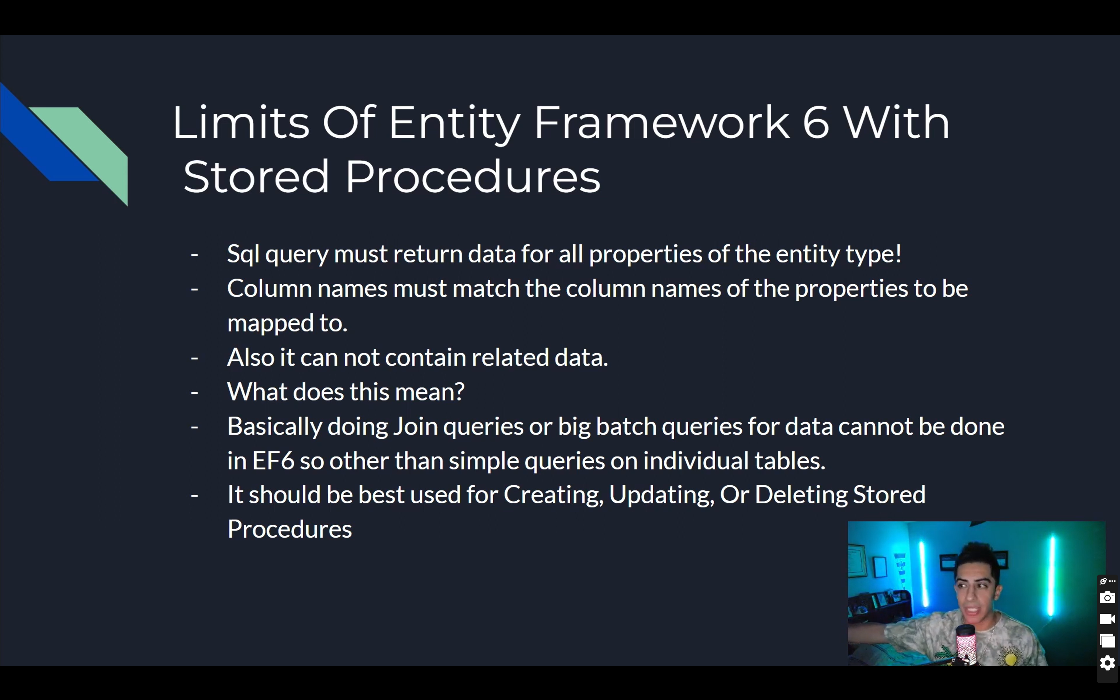

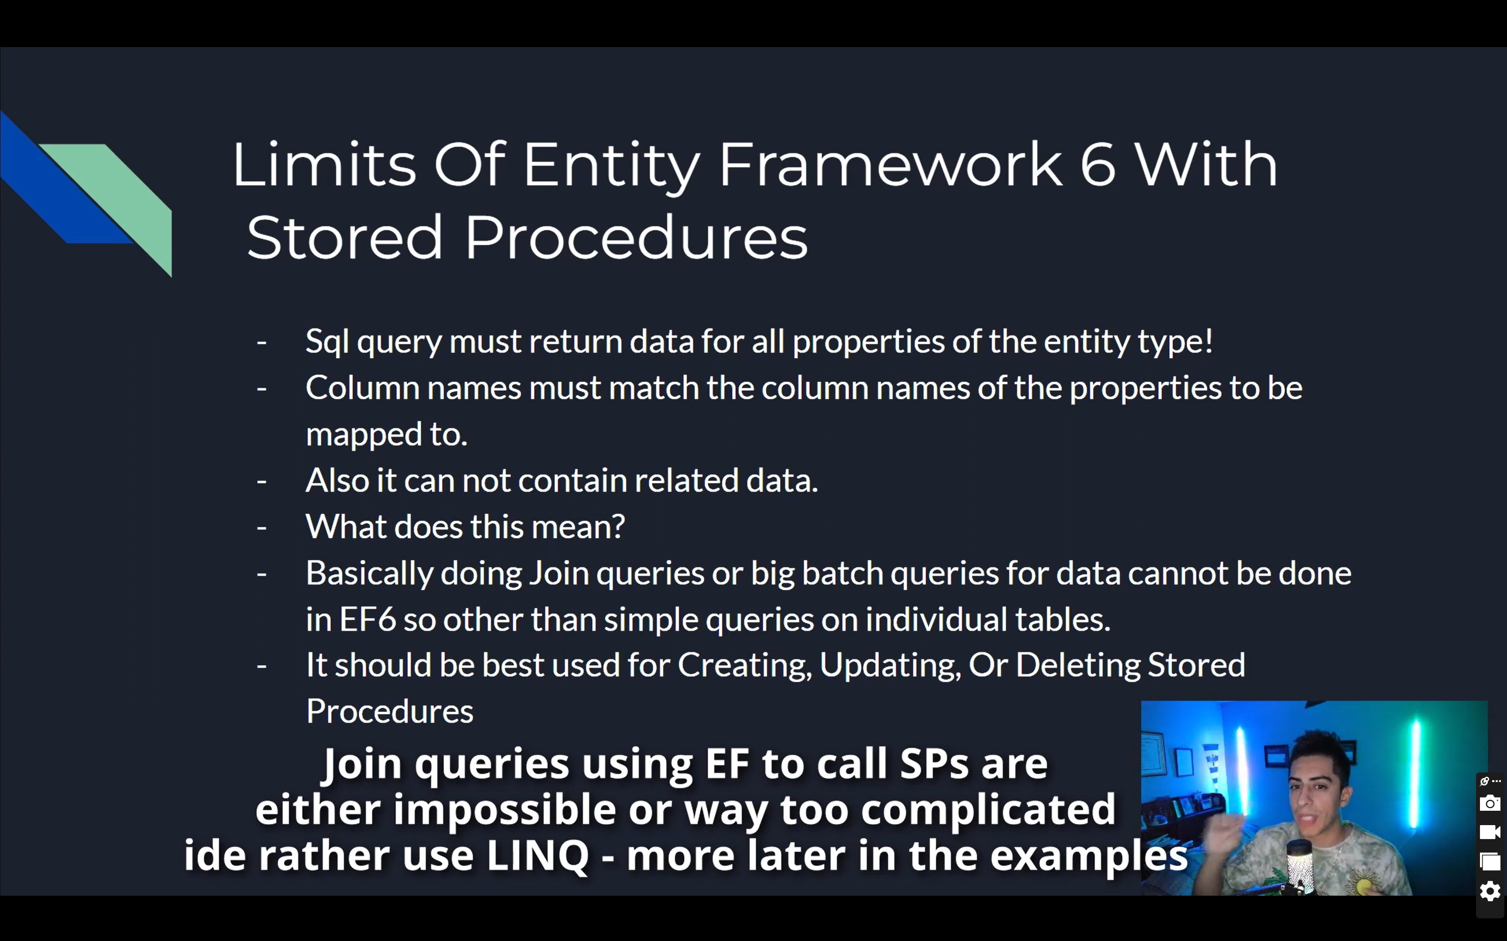

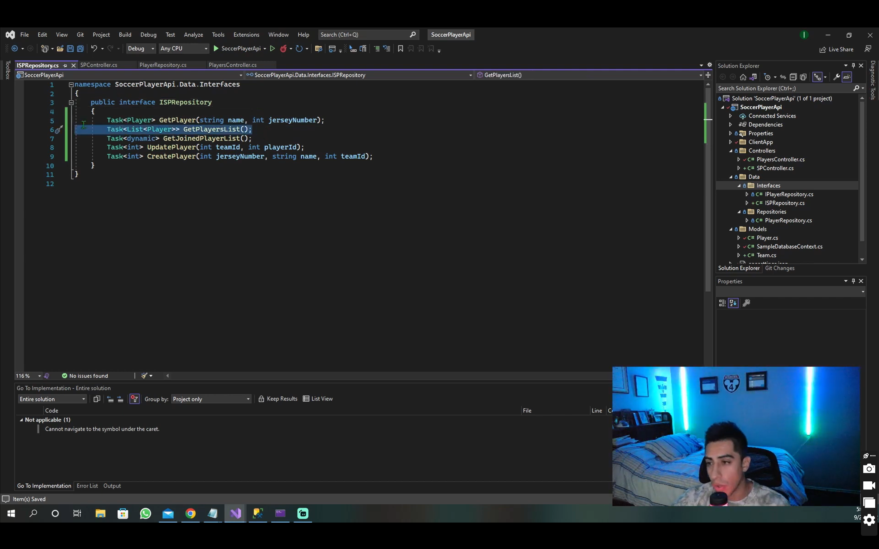

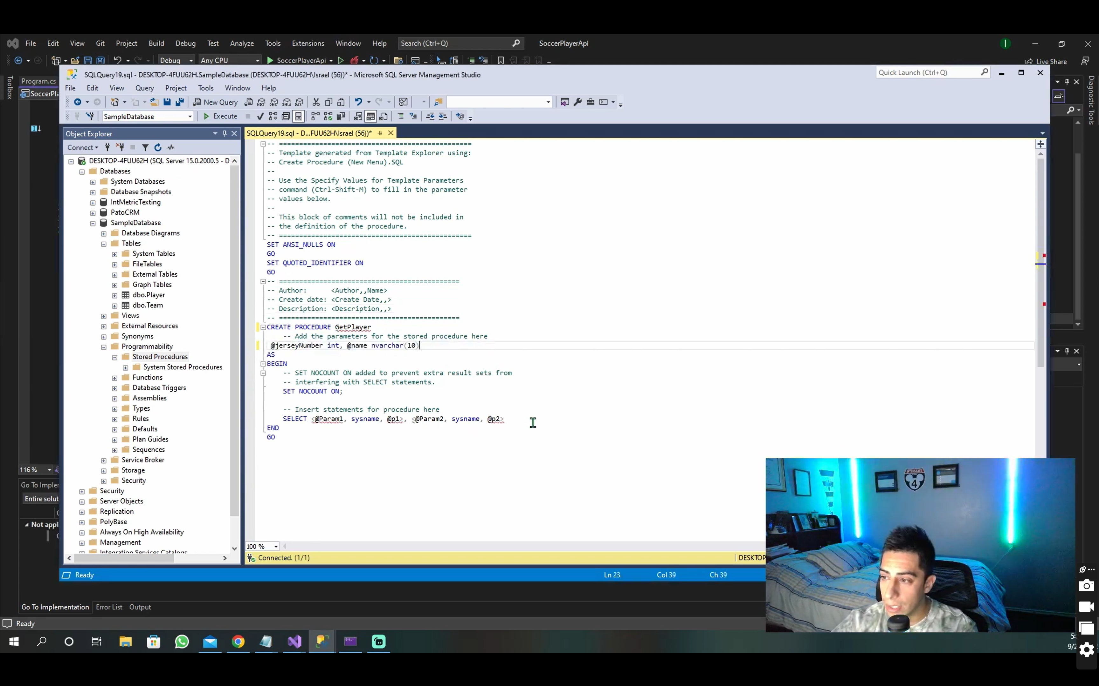

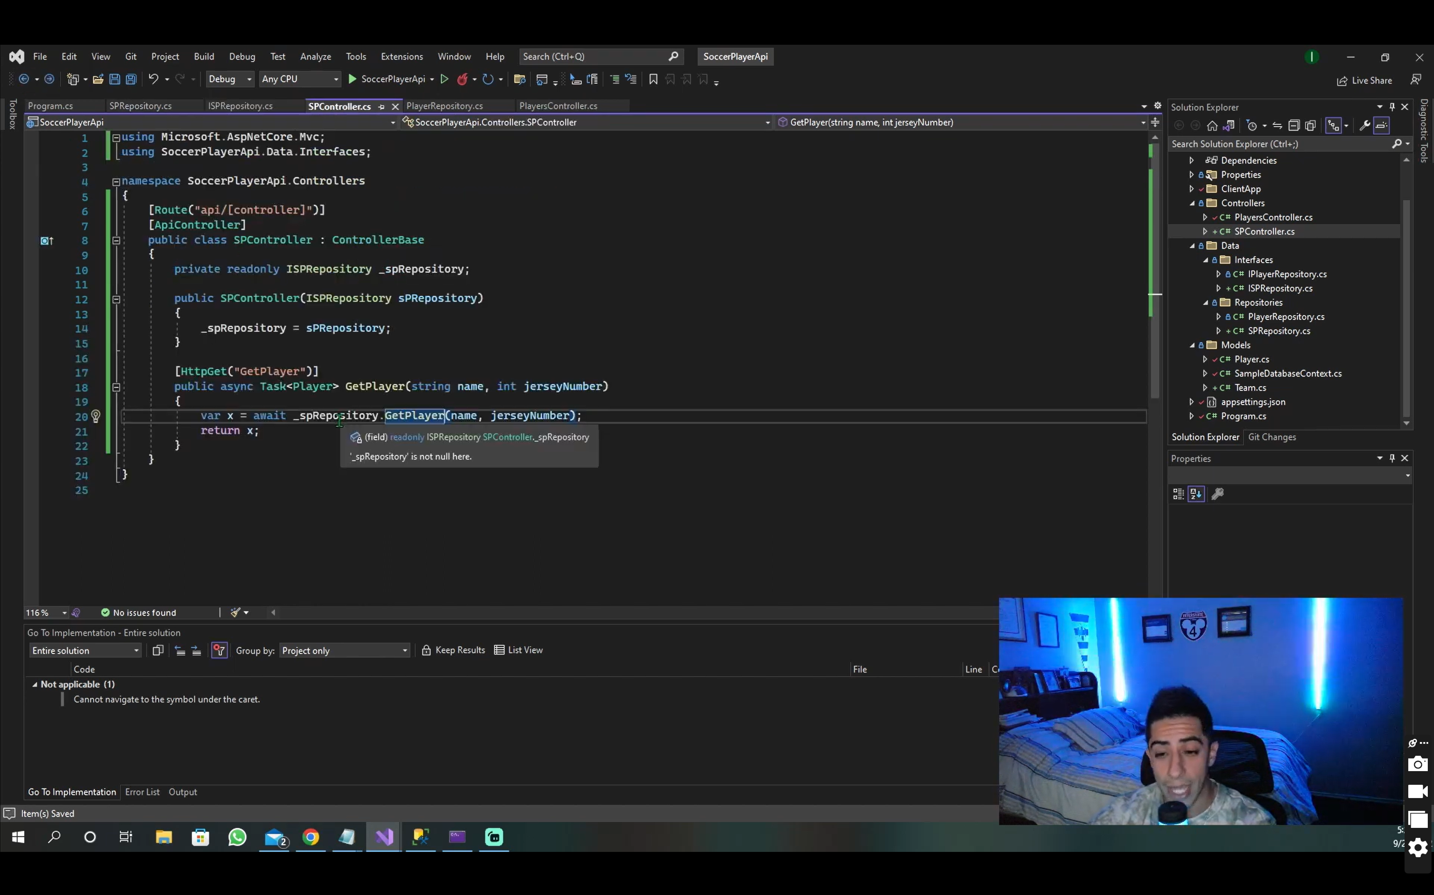

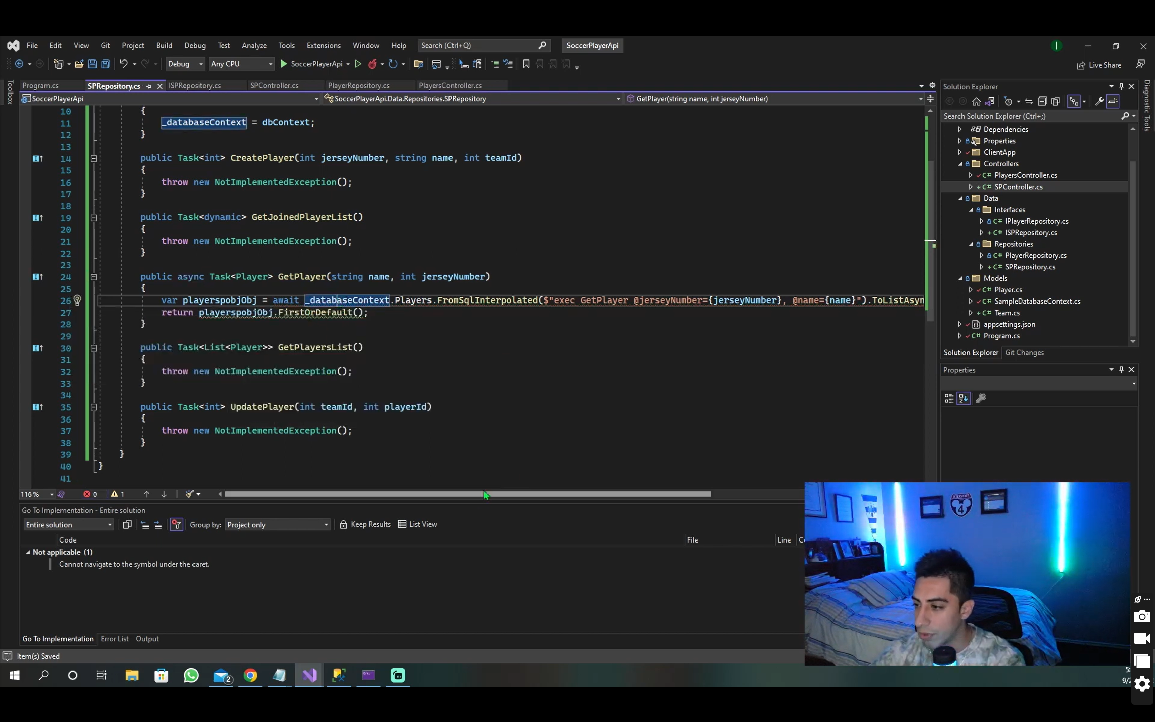

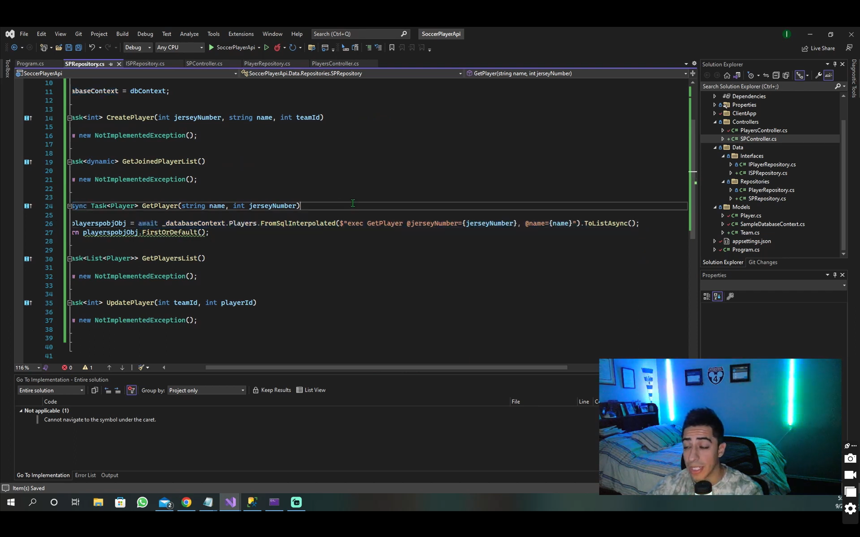

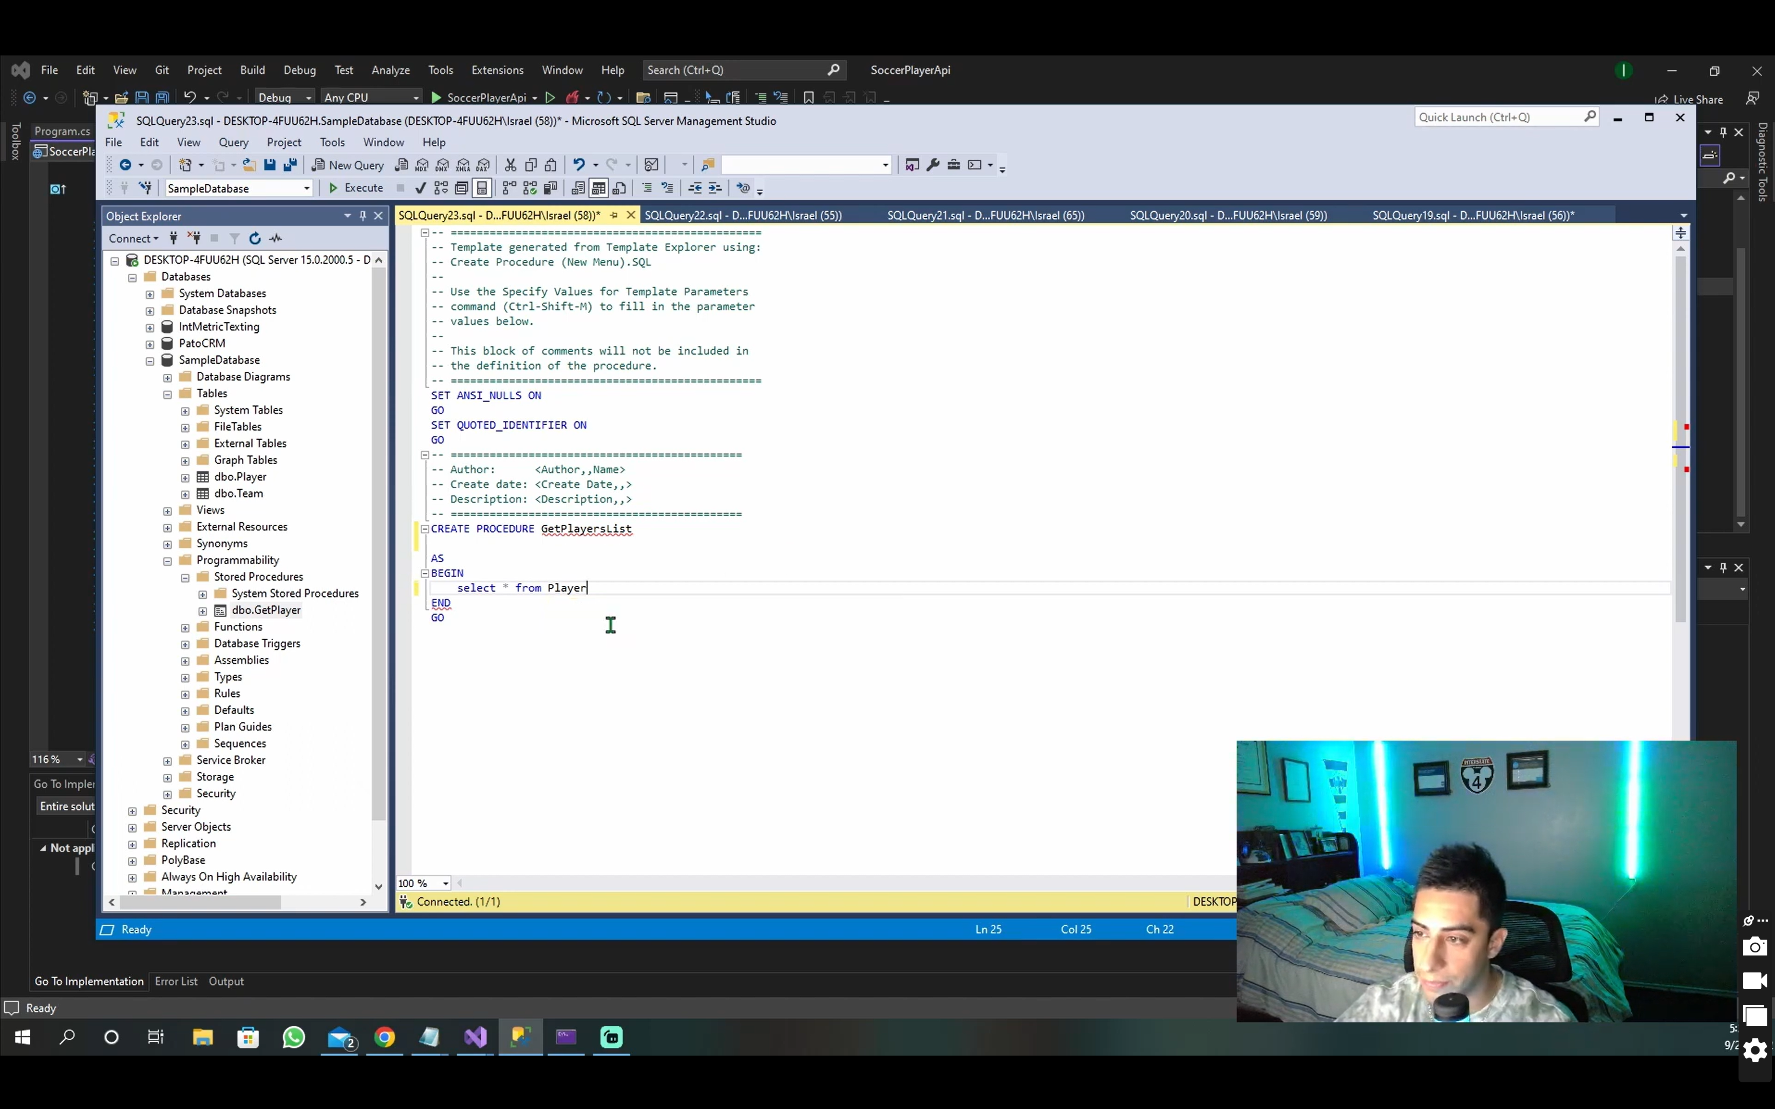

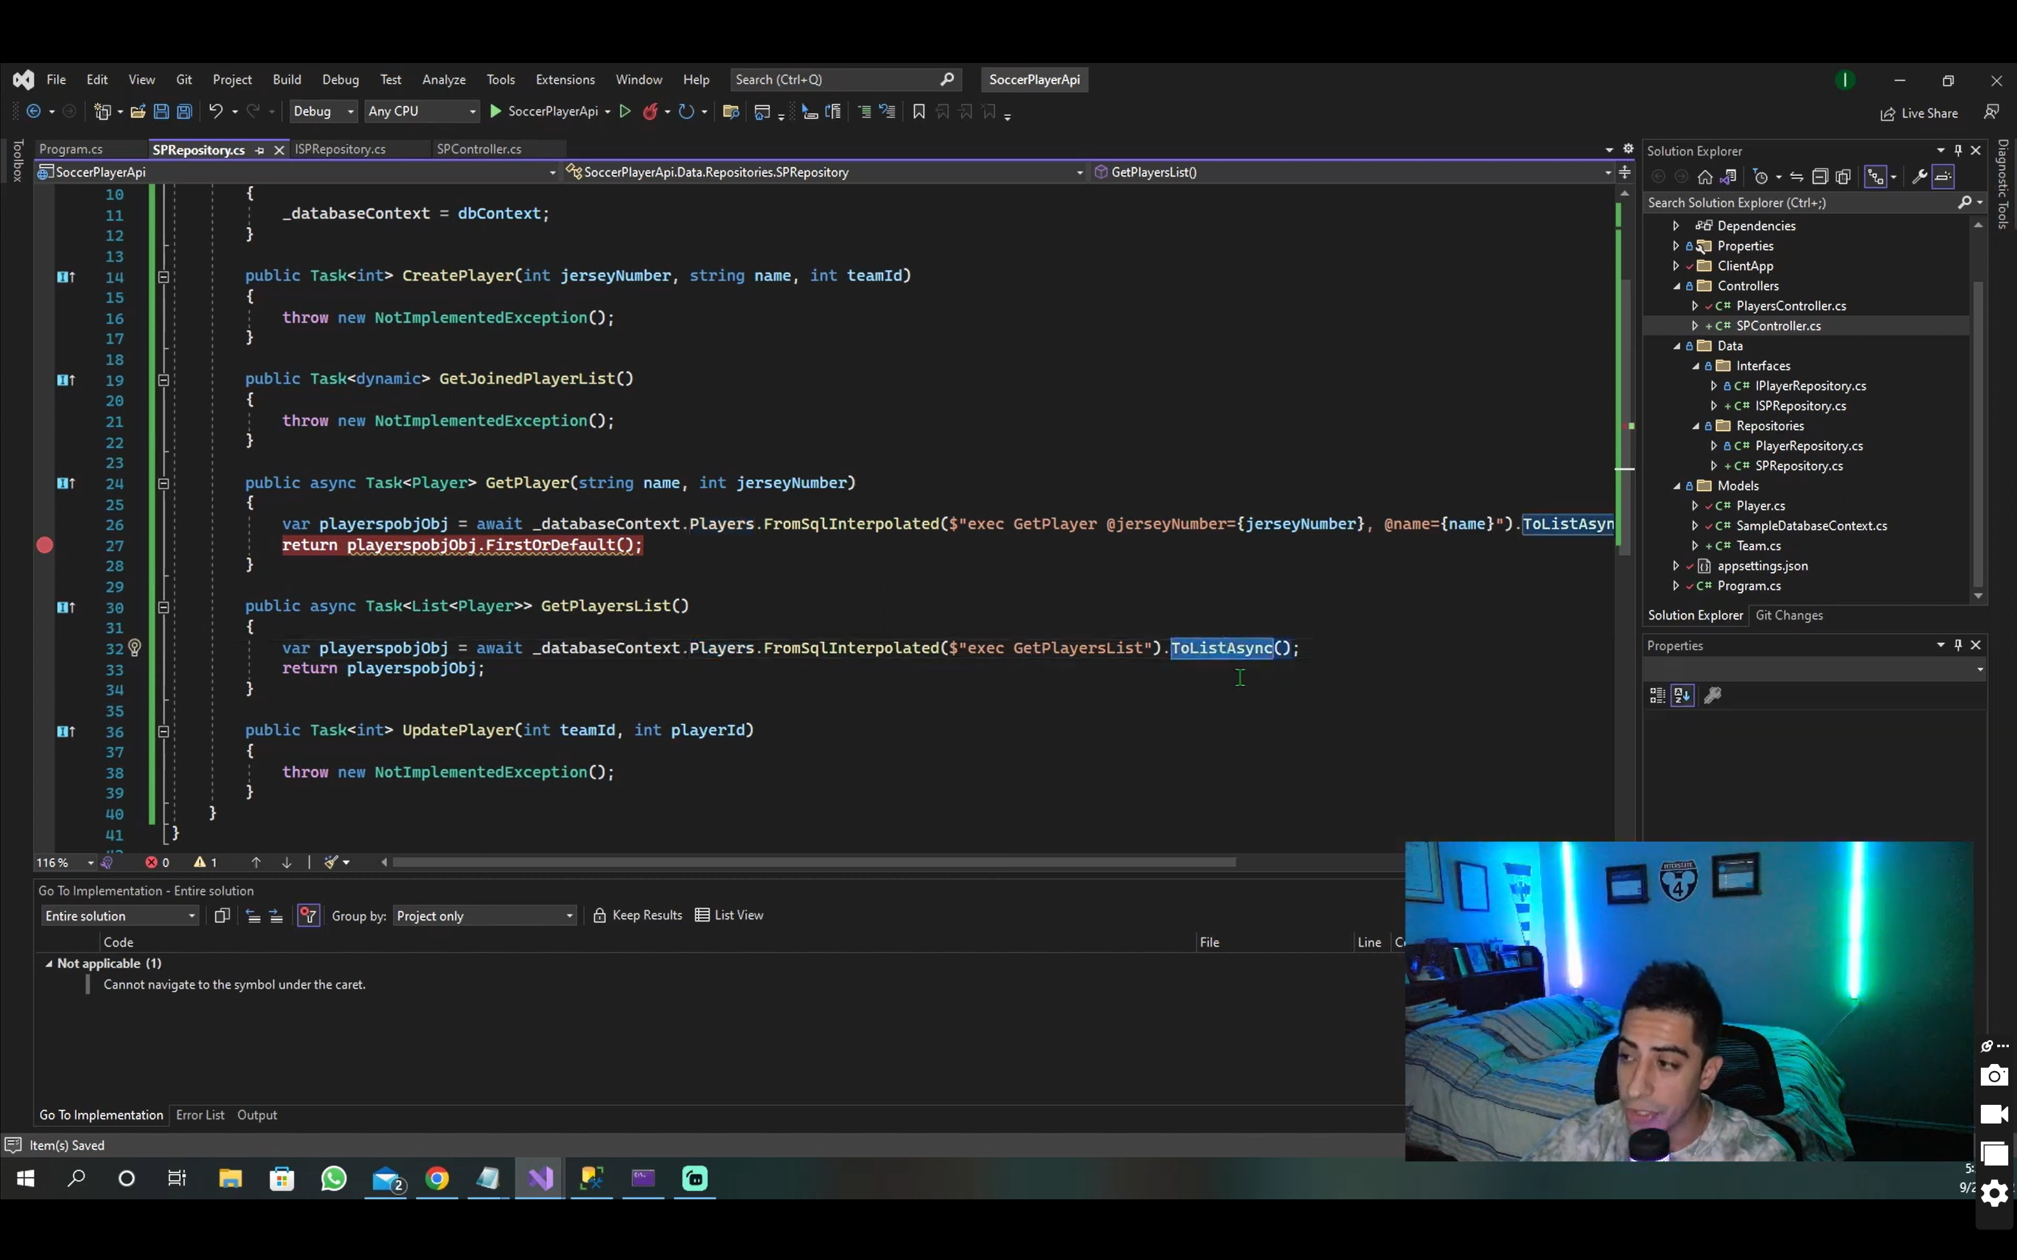

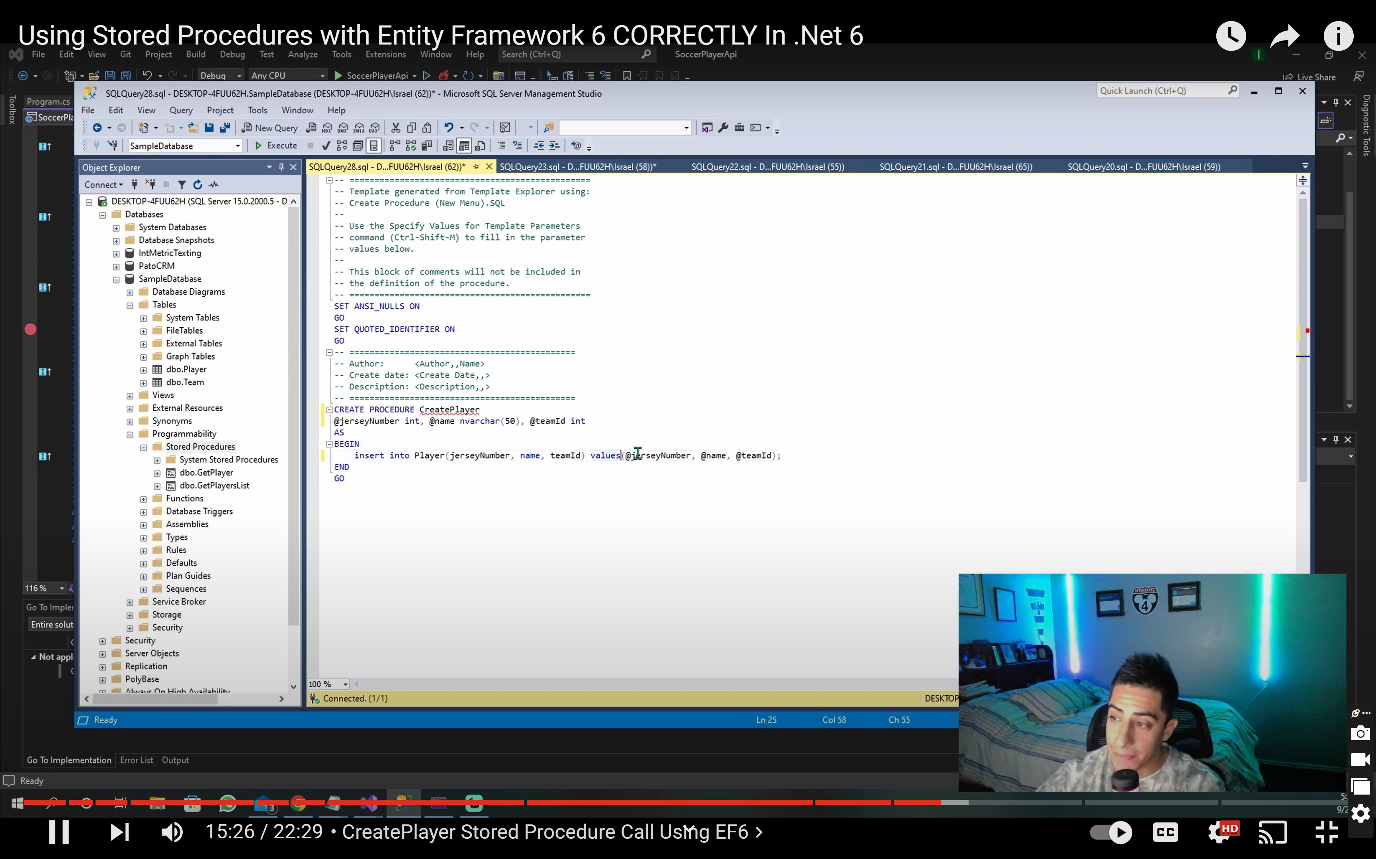

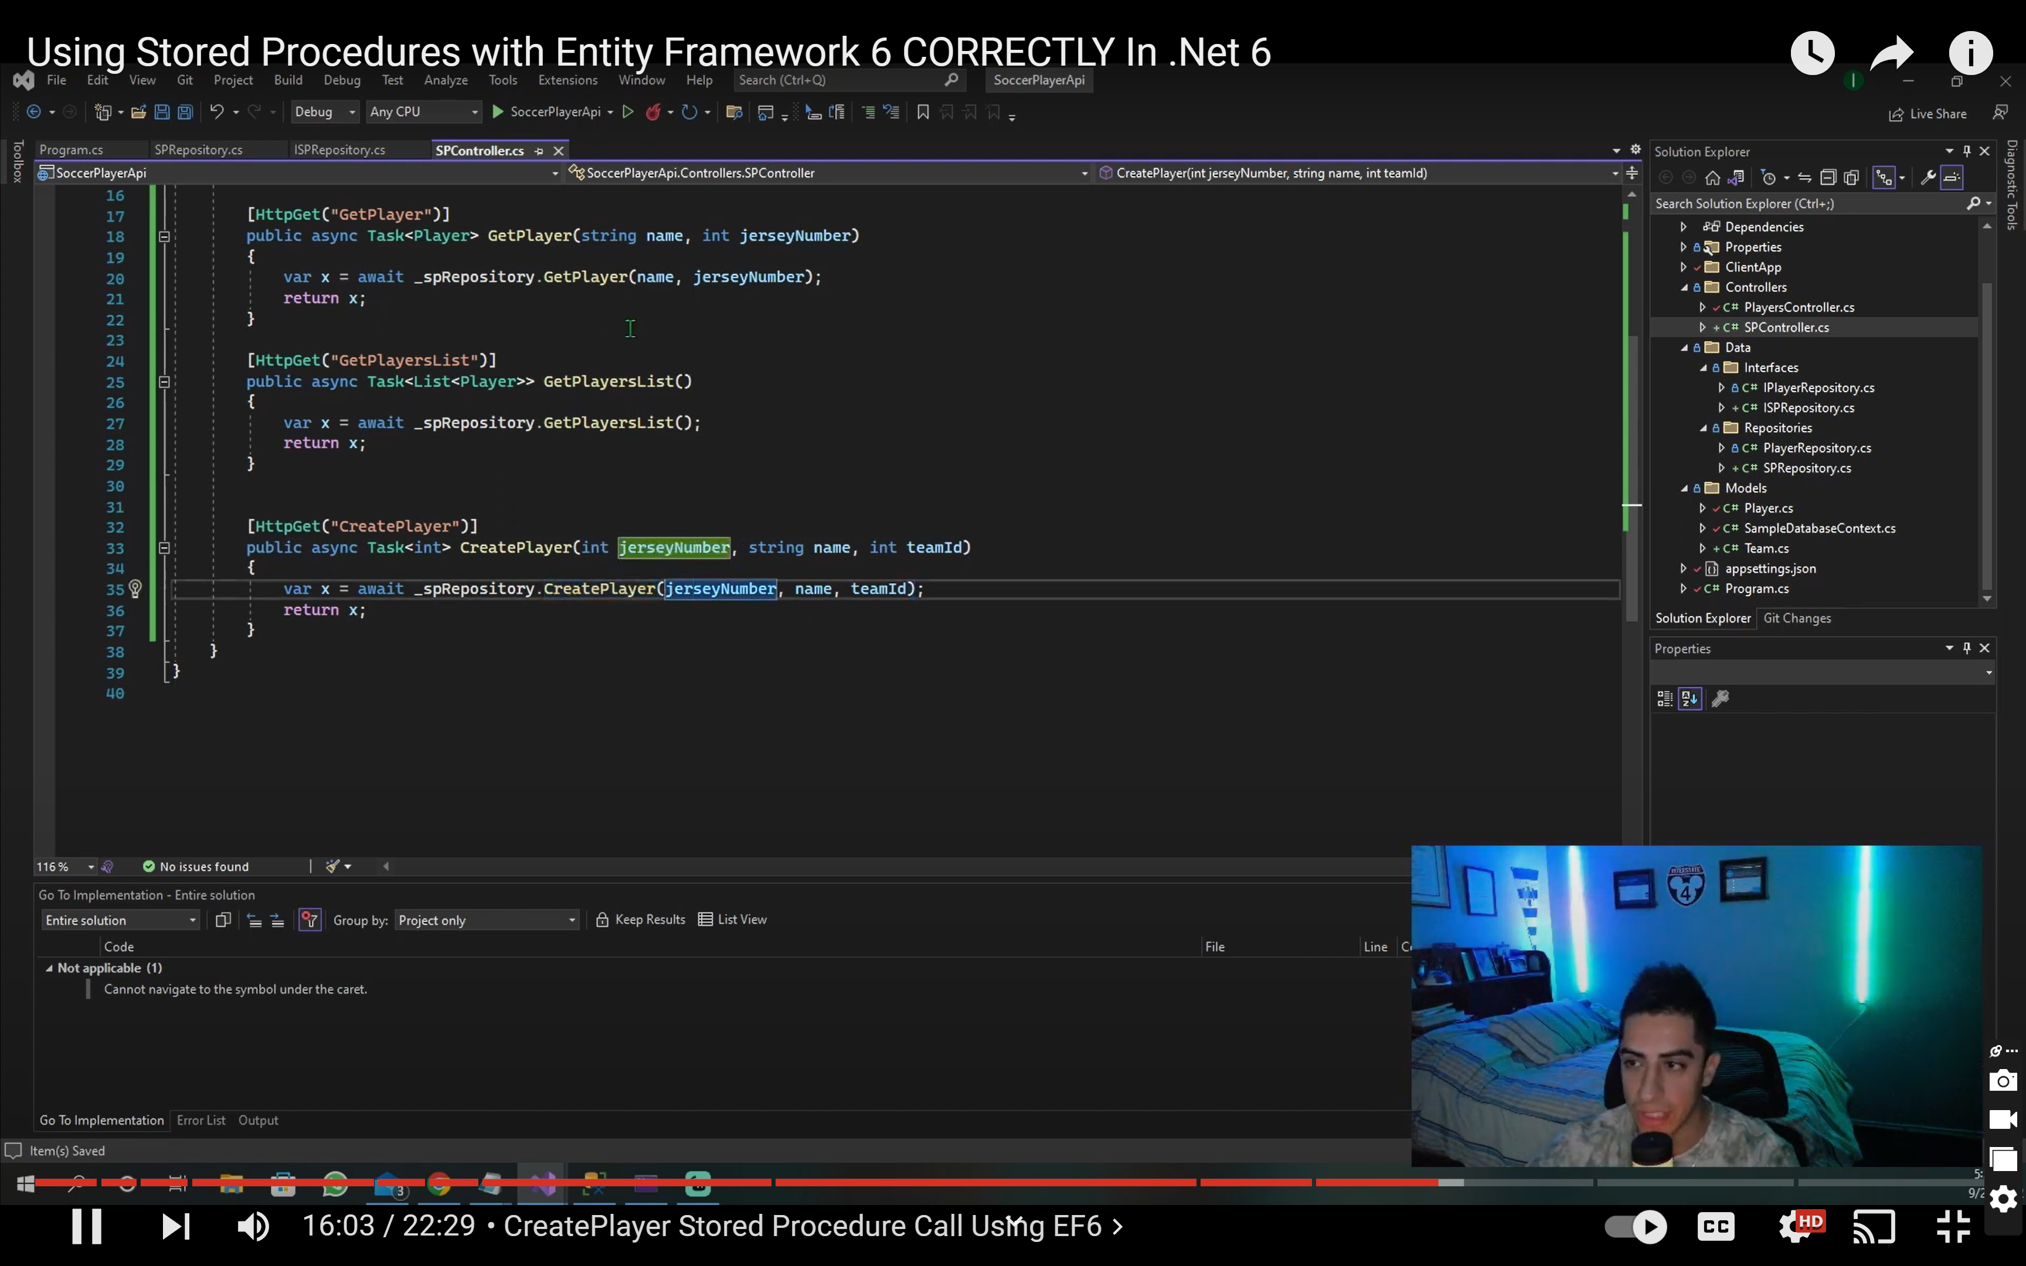

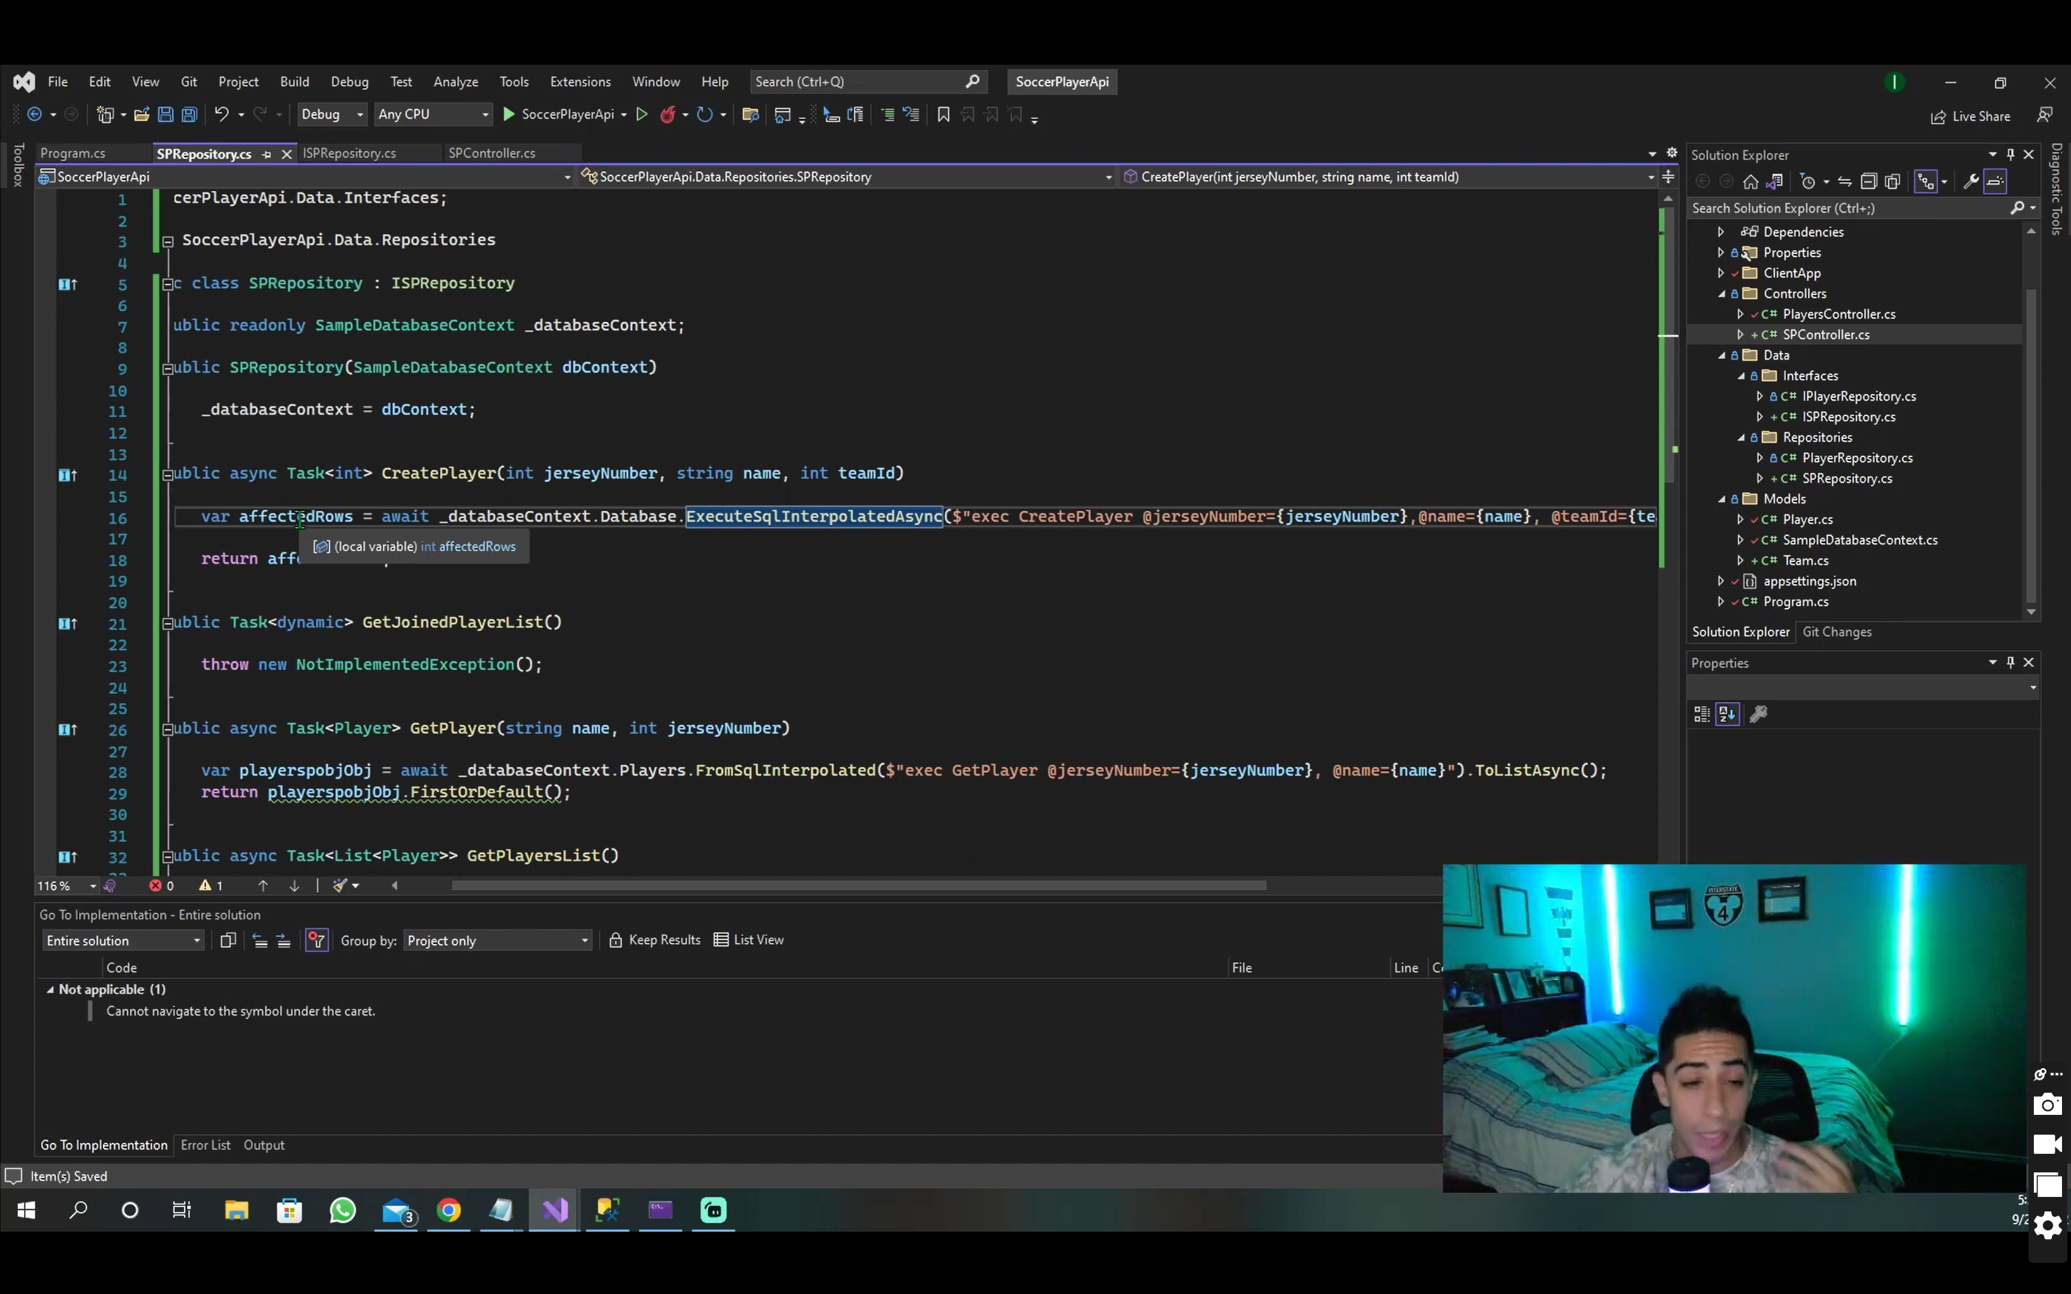

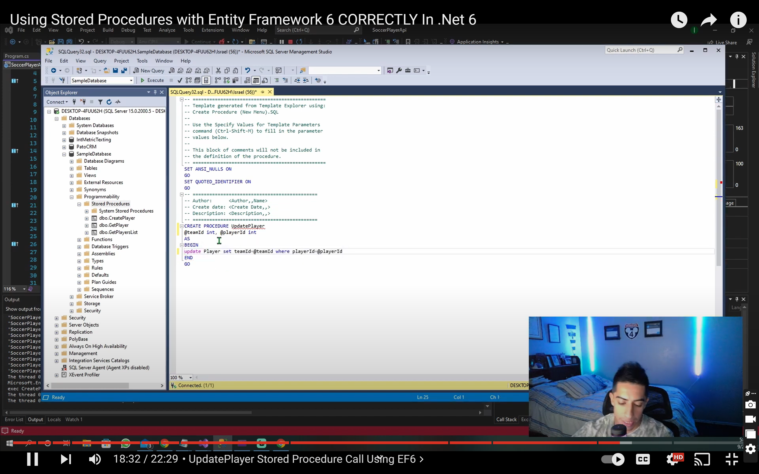

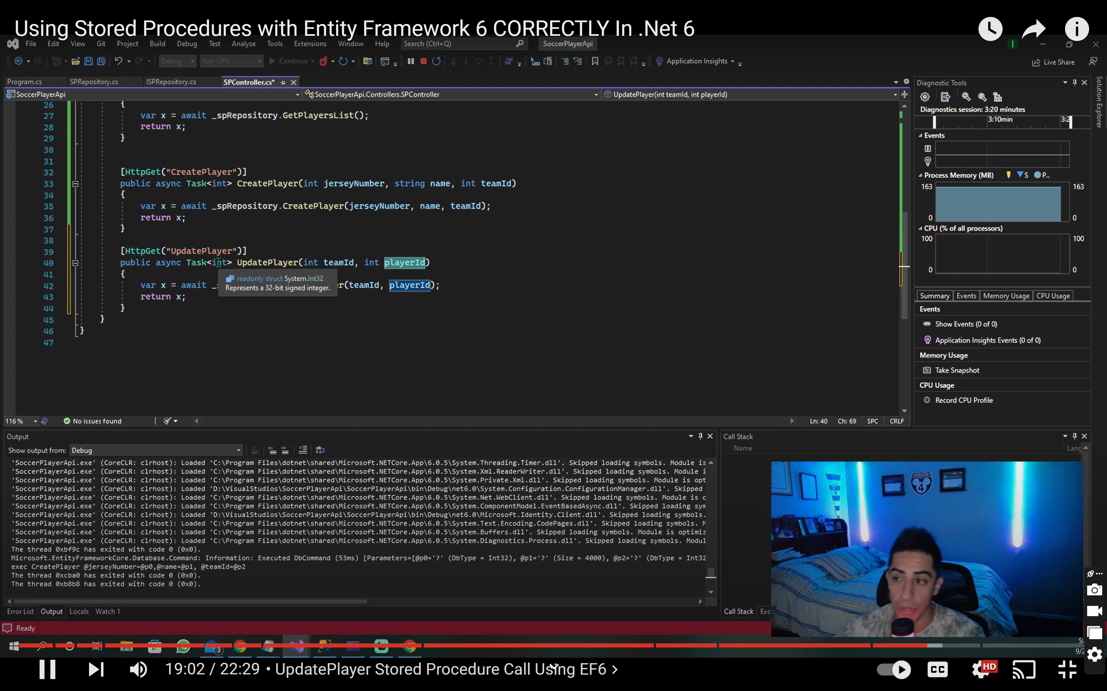

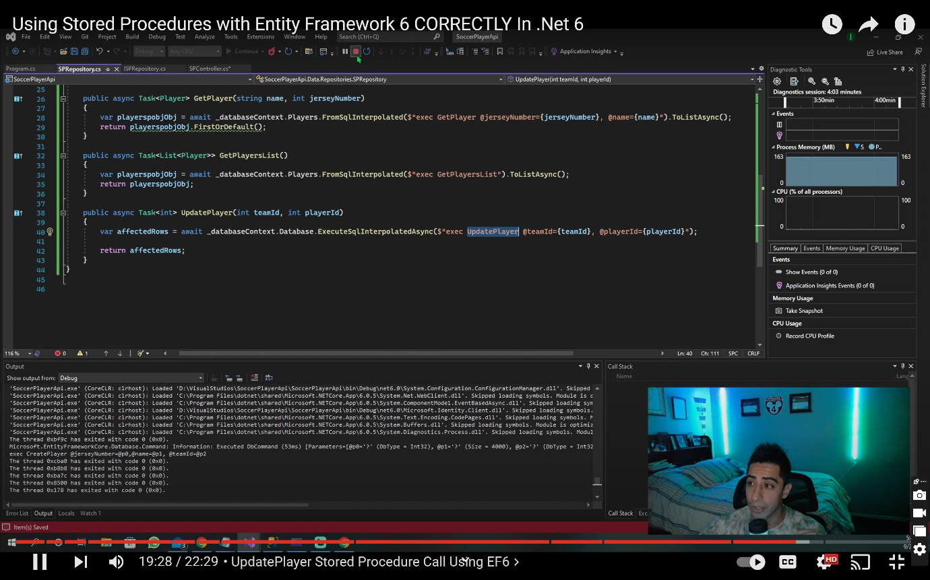

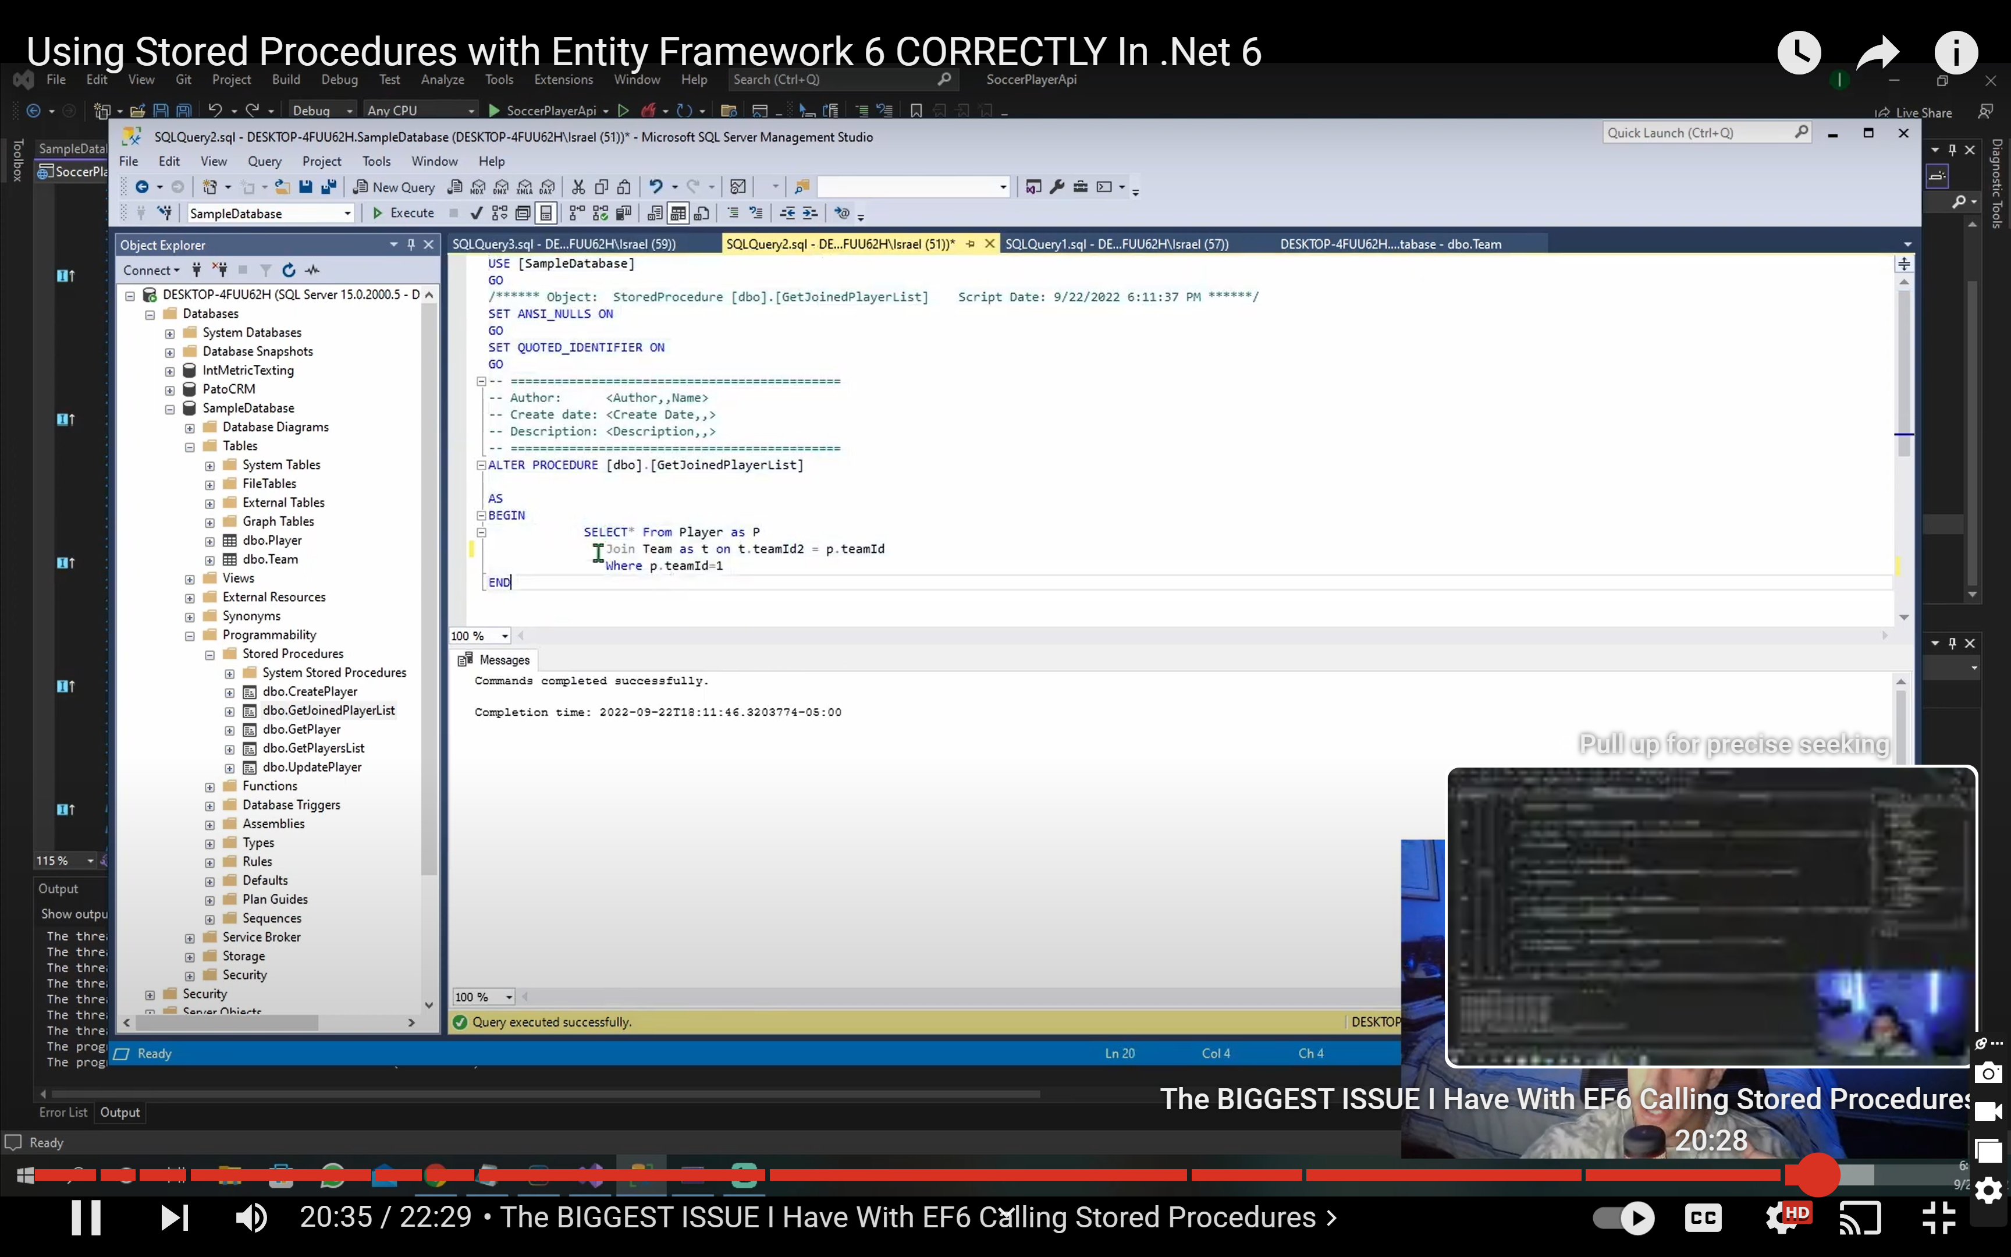

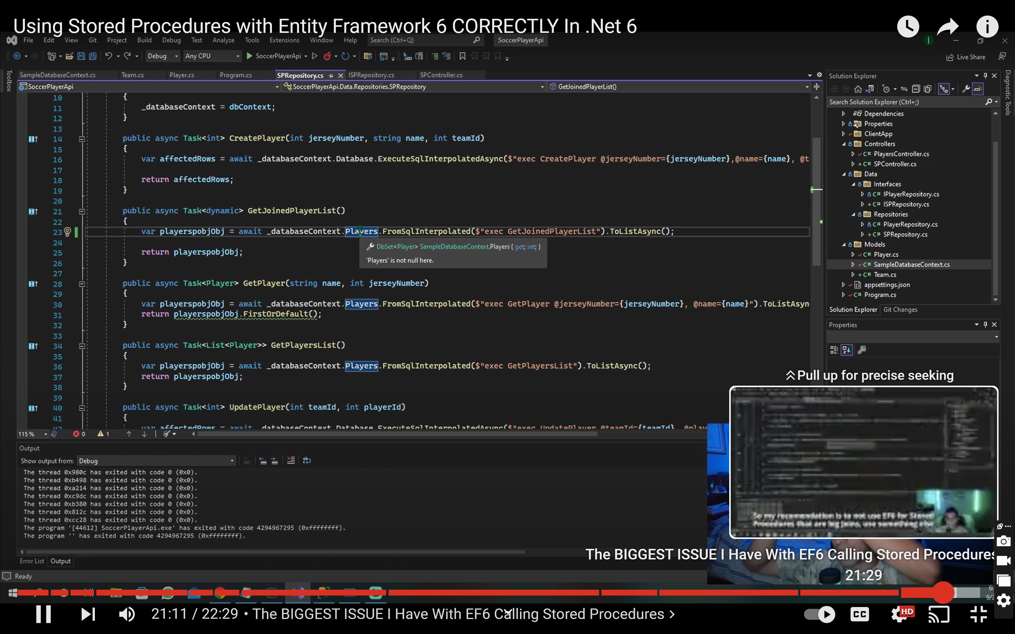

UDF

create function GetStudentsCount()

returns int

begin

declare @count int

select @count = count(*) from students

return @count

End

select dbo.GetStudentsCount()

public int GetStudentsByCount()

=> throw new NotSupportedException();

protected override void OnModelCreating(ModelBuilder modelBuilder)

{

modelBuilder.HasDbFunction(typeof(StudentDbContext)

.GetMethod(nameof(GetStudentsByCount)

/* new[] { typeof(int) }*/))

.HasName("GetStudentsByCount");

In Repo.cs file

public int GetStudentsCount()

{

int x = _context.GetStudentsByCount();

return x;

}

[EF Core 5: Mapping user-defined functions - All Hands on Tech](https://www.allhandsontech.com/data-professional/entityframework/entity-framework-core-advanced-mapping/)